From: | David H.W. Morgan  Chief, Scientific Support Unit  CITES Secretariat | Date: | 28 August 2008
Subject: | Decision 14.103

1. Decision 14.103 directs the Secretariat to distribute a Notification to the Parties on implementation of listings for shark species focussed specifically on obtaining from Parties’ Scientific and Fishery Authorities case studies on the development of non-detriment findings for shark species. The Secretariat is directed to collate and summarize these for provision to the international expert workshop on non-detriment findings (IEWNDF) to be held in Mexico.
2. After consulting the co-chairmen of the IEWNDF WG8 on fishes about the sort of information that they would wish to receive, the Notification in question (No. 2008/044) was distributed on 8 July 2008.
3. Four replies were received: from New Zealand, Norway, the United Kingdom of Great Britain and Northern Ireland and the United States of America. It appears that only New Zealand has made non-detriment findings for a CITES-listed shark species, Cetorhinus maximus (basking shark). The trade was authorized by the Scientific Authority of New Zealand because the fins were sourced from sharks caught in bycatch.
4. Both New Zealand and the United States of America provide links to information about fishing protocols established or undertaken in their territory for non-CITES shark species and these may or may not be applicable to species which are listed in the Appendices of the Convention.
5. The full text of the replies received from these three Parties can be found in the Annex to this memorandum.

Annex
Text of responses received to Notification to the Parties No 2008/044 of 8 July 2008
NEW ZEALAND

wjackson@doc.govt.nz
08/05/2008 06:16 AM

To Jonathan.BARZDO@cites.org, david.morgan@cites.org
Cc RHAY@doc.govt.nz, pamela.mace@fish.govt.nz

Subject: NZ response to Notification regarding shark NDFs

Dear CITES Secretariat,

As indicated in the table below, New Zealand's trade in shark species is limited to three years of fin exports of Cetorhinus maximus (basking shark). Trade in these specimens was authorised by the Scientific Authority on the basis that - because the fins were sourced from sharks caught in bycatch - a non-detriment finding could be issued. The number of fins exported (in table below) represents up to seven fins per shark. However, recognising that these sharks have low productivity and that the stock range is unknown, New Zealand is currently initiating a number of activities to review their productivity and protect the species.

Year | App | Taxon | Imp | Exp | Quantity | Term | Purpose | Source
2004 | 2 | Cetorhinus maximus | SG | NZ | 21 | fins | T | W
2005 | 2 | Cetorhinus maximus | SG | NZ | 8 | fins | T | W
2006 | 2 | Cetorhinus maximus | SG | NZ | 39 | fins | T | W

Special mention of protection of basking shark has been made in the draft National Plan of Action for the Conservation and Management of Sharks (NPOA-Sharks:
http://www.fish.govt.nz/NR/rdonlyres/94D86BF9-CF41-4BA5-9BCC-CA65DF7A7560/0/NZ_draft_NPOAsharks.pdf).

This document was released by the Ministry of Fisheries in October 2007, with submissions due in February 2008. While the draft NPOA-Sharks is still under consideration, another process has been initiated: tendering for a research project on the bycatch of basking shark by the Ministry of Fisheries. The document (which has one section on the project investigating the bycatch of basking sharks) can be found here:
http://www.fish.govt.nz/NR/rdonlyres/760CF8B7-77A3-48C4-8067-0C15567DA370/0/AquaticEnvironmentRoundOne2008.pdf.

It is expected that this research - which will feed directly into the NPOA-Sharks process - will start in October 2008 and conclude in September 2009.

In direct response to the three questions:

1. There is no directed catch of basking shark. Bycatch - 203 specimens observed between 1986-1999 (Francis and Duffy 2002) - is by commercial trawlers in the hoki and barracouta fisheries. Access to these vessels is through monitoring, control and surveillance mechanisms administered by the Ministry of Fisheries.
2. A response to this should be clear after the MFish research is concluded in September 2009.
3. A response to this should be clear after the MFish research is concluded in September 2009.

Please contact me should you require further information or if you have any questions.

With kind regards,
Wendy

CITES Management Authority
Department of Conservation / Te Papa Atawhai
18-32 Manners Street
PO Box 10-420
Wellington, New Zealand
Tel: +64 (0)4 471 0726 (ext. 8106)
Direct line: +64 (0)4 471 3106

NORWAY

Øystein Størkersen <Oystein.Storkersen@DIRNAT.NO>
08/18/2008 11:57 AM

To "david.morgan@cites.org" <david.morgan@cites.org>
cc Gunn Paulsen <Gunn.Paulsen@DIRNAT.NO>, Johansen Halvard P <Halvard.Johansen@fkd.dep.no>, Tallaksen Einar <einar.tallaksen@mfa.no>, Winsnes Inger <Inger.Winsnes@md.dep.no>

Subject. On NDF and sharks

Dear David

I refer to the Secretariat’s notification on sharks and NDFs…… These are our official comments to the bullet points in the notification:

There is no directed Norwegian fishery after shark spieces, but sharks are caught as bycatch mainly in the fishery with nets and long line, mostly by small coastal vessels and to a lesser degree by vessels (longliners) that operate outside Norwegian coastal waters. If necessary, Norwegian authorities have by law access to all Norwegian fishing vessels.

Three shark species were reported to be in the Norwegian commercial catches: porbeagle (Lamna nasus), basking shark (Cetorhinus maximus) and spiny dogfish (Squalus acanthias). Recently, targeting these three species was banned (with som exceptions for spiny dogfish), however, those caught as bycatch are legal. Data are not available for estimating fishing effort (and thereby mortality) for these species, but the reported catches are so small that it is very unlikely that the fisheries have any effect on stock abundance. Therefore, the threat by the Norwegian fisheries to their conservation status is minimal.

Best regards Øystein Størkersen
Directorate for Nature Management, Norway

UNITED KINGDOM OF GREAT BRITAIN AND NORTHERN IRELAND
"Beaufort, Lynn (WSC)" <Lynn.Beaufort@defra.gsi.gov.uk>
21/08/2008 17:09

To "Robert BOLJESIC" <Robert.BOLJESIC@cites.org>, "Milena SOSA SCHMIDT" <Milena.Schmidt@cites.org>
cc "Hughes, Stacey (WSC)" <Stacey.Hughes@defra.gsi.gov.uk>, <Henk.EGGINK@ec.europa.eu>

Subject: CITES Notification E044

Good Afternoon All
At its 14th meeting the CoP adopted decision 14.103 on the implementation of listings of shark species. Under notification 044 you have asked for case studies on non-detriment findings for the shark species concerned ahead of the non-detriment findings workshop in Mexico.
We have no targetted fisheries in the UK on the shark species in question. We do have a record of 1 basking shark being caught up in gill net in 2002 and that is all.
We also have no exports of shark species and therefore no non-detriment findings. So a nil return from the UK.
Regards
Lynn Beaufort
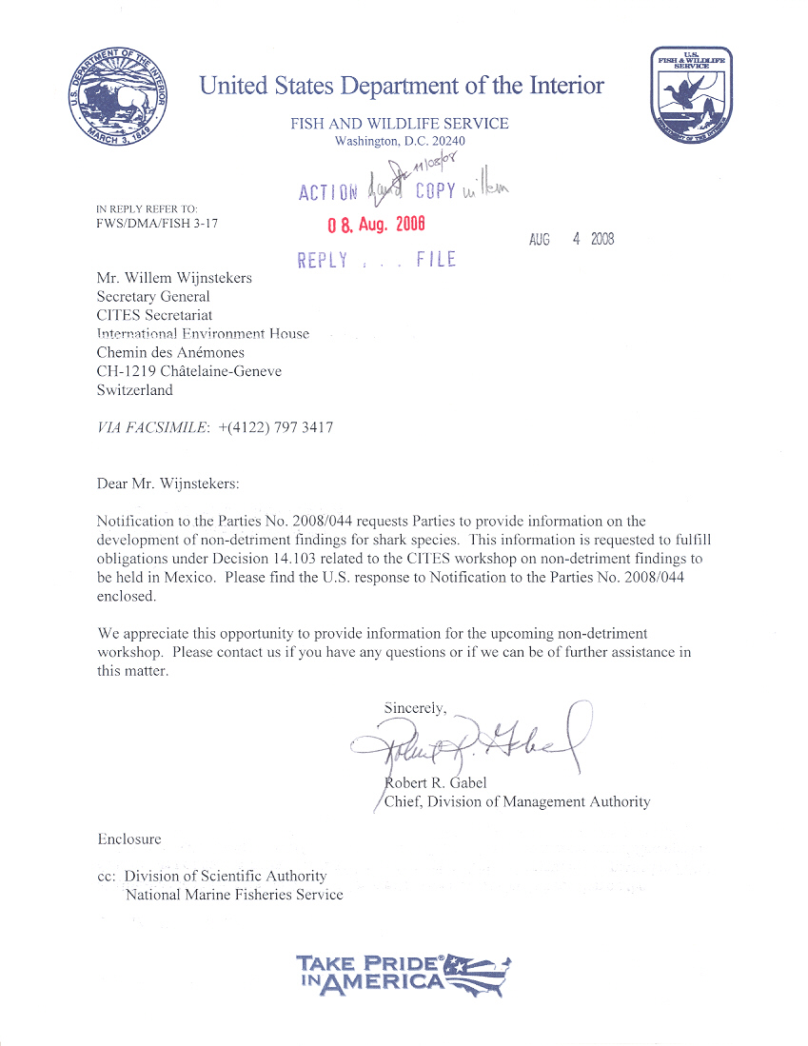
UNITED STATES OF AMERICA
